BATES DRIVE
SCHOOL

School Handbook
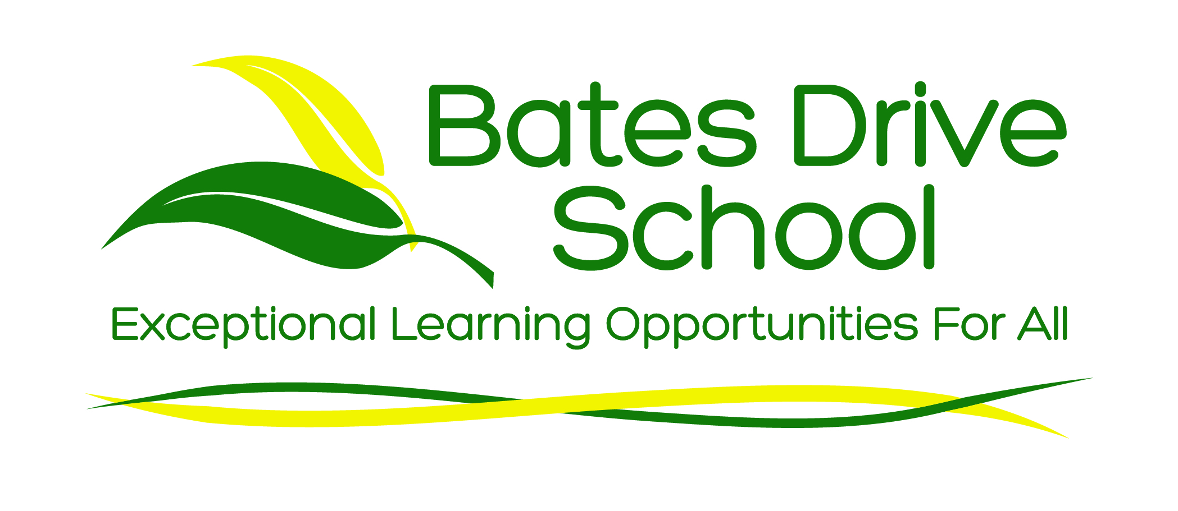

Bates Drive School and its community are committed
to providing students with a valuable, holistic and appropriate curriculum.

Our mission is to provide exceptional learning opportunities for all.

2017

Welcome

Welcome to Bates Drive School community. We are proud of our school, its students, parents/carers, staff and the wide range of educational opportunities that are provided here.

The purpose of this booklet is to provide you with information and suggestions that may assist you in meeting the needs of your child as he/she commences at this school. Please do not hesitate to contact any member of staff if we can be of assistance to you and your child.

We are very fortunate to have an experienced and dedicated teaching and support staff whose aim is to provide the best education for each child through our many and varied programs.

School Staff

PRINCIPAL: Ms Robyn Compton
ASSISTANT PRINCIPALS: Mrs Vanessa Marsden
Ms Anne-Marie Napier
Ms Chris Mealey (Rel. P/T)
Mrs Nicole Pitt (P/T)

SCHOOL ADMINISTRATION: Mrs Karen Coughlan
MANAGER

ADDRESS: Bates Drive
KAREELA NSW 2232

PHONE: 9521 6049

FAX: 9545 3317

EMAIL: batesdrive-s.school@det.nsw.edu.au

WEB SITE: www.batesdrive-s.school.nsw.edu.au

School Structure
Bates Drive School is a school for students who have a moderate/severe intellectual disability, autism and physical disabilities. The ages of the 65 students enrolled range from 5-18 years. There are 11 classes within the school.

The school provides the opportunity for students to gain a Record of School Achievement RoSA (Life Skills) Year 10 and Higher School Certificate (Life Skills) Year 12.

Rationale
At Bates Drive School our student welfare procedures involve the whole school in maintaining a community that meets the personal, social and learning needs of the students.

This will be achieved by providing a safe, secure and supportive learning environment for all.

Our Priorities
The school’s priorities for our teaching and learning programs are:
- providing a strong literacy/communication foundation;
- providing appropriate numeracy experiences;
- incorporating technology in all curriculum areas to enhance learning; and
- providing community based activities and experiences to broaden students’ learning.

Underlying each of these priorities is our belief in high expectations for student learning and the need to continually initiate improvements to ensure the best possible educational, social and physical outcomes for all students to reach their personal potential.

We hope that your child’s time at our school will be enjoyable, rewarding and beneficial.

Bell Times

Morning 8.50am (arrival) then 9.10am (classes commence)
Morning Tea 11.00am – 11.40am
Lunch 1.10pm – 1.50pm
Home Bell 2.50pm for Buses at 3.00pm

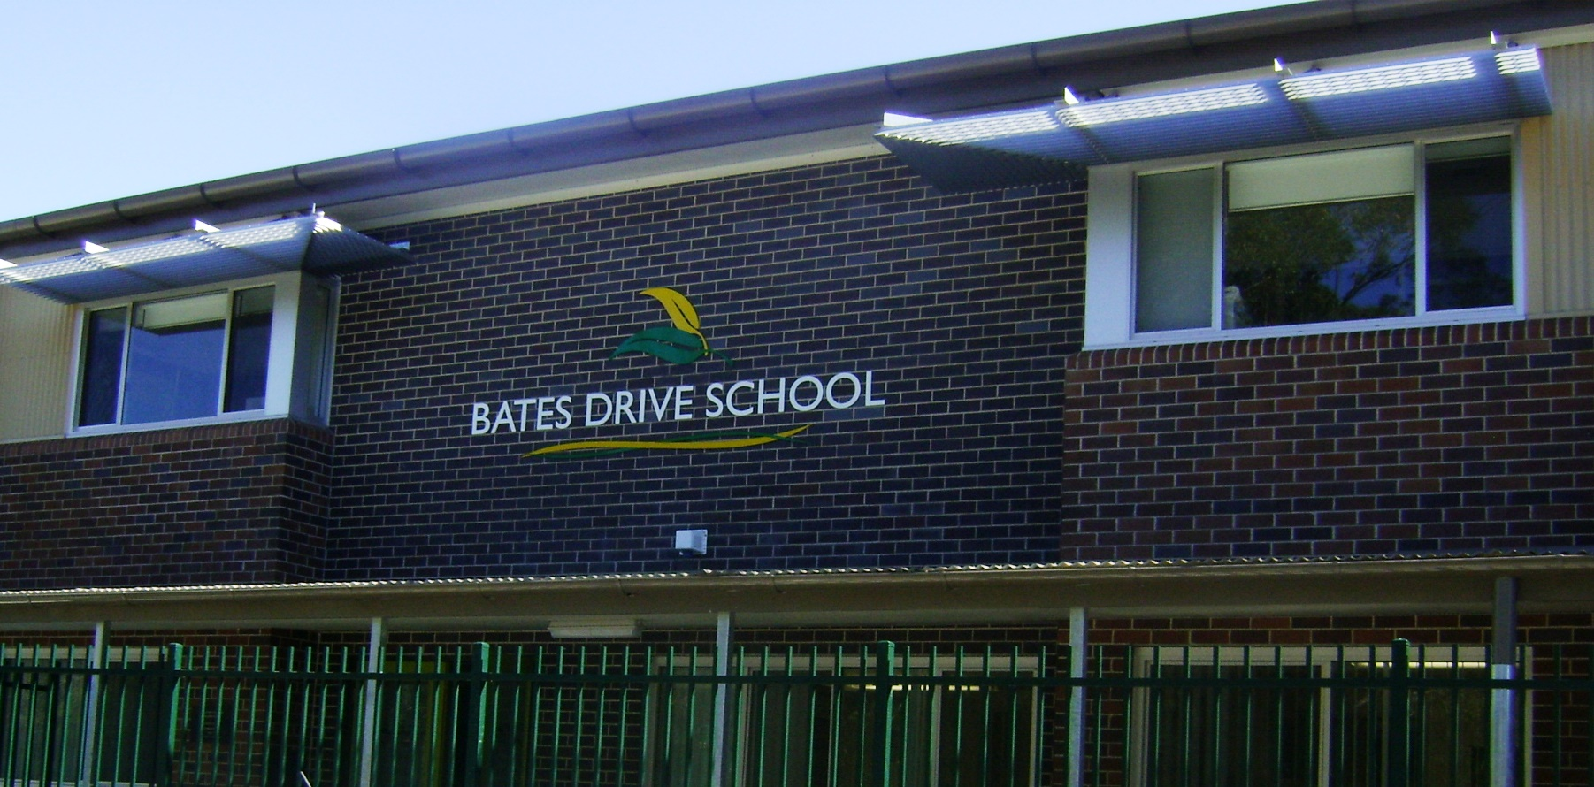

School Uniform
We expect all students to wear the correct uniform at school, during school functions and on excursions. By wearing our uniform we identify with the school and take great pride in being a part of the Bates Drive School Community.

Winter Summer
High School
School Polo Shirt School Polo Shirt
Bottle Green Track Pants or Grey Shorts /Slacks (males)
Grey Slacks (males) Green Shorts/Slacks (females)
Bottle Green School jacket Bottle Green School jacket
or tracksuit top or tracksuit top

Infants/Primary
School Polo Shirt School Polo Shirt
Bottle Green Track Pants Grey Shorts (boys) Green Shorts (girls)
Bottle Green School jacket or Bottle Green School jacket or tracksuit top tracksuit top.

Joggers/runners or black school shoes.

Uniforms are available from school at cost price.

Swimming
During the summer months all students will need a swimming costume and towel. Goggle and cap are optional.

ALL CLOTHING SHOULD BE LABELLED WITH THE CHILD’S NAME.
Students should always be appropriately dressed by wearing clothes that are clean and meet the school’s dress code.

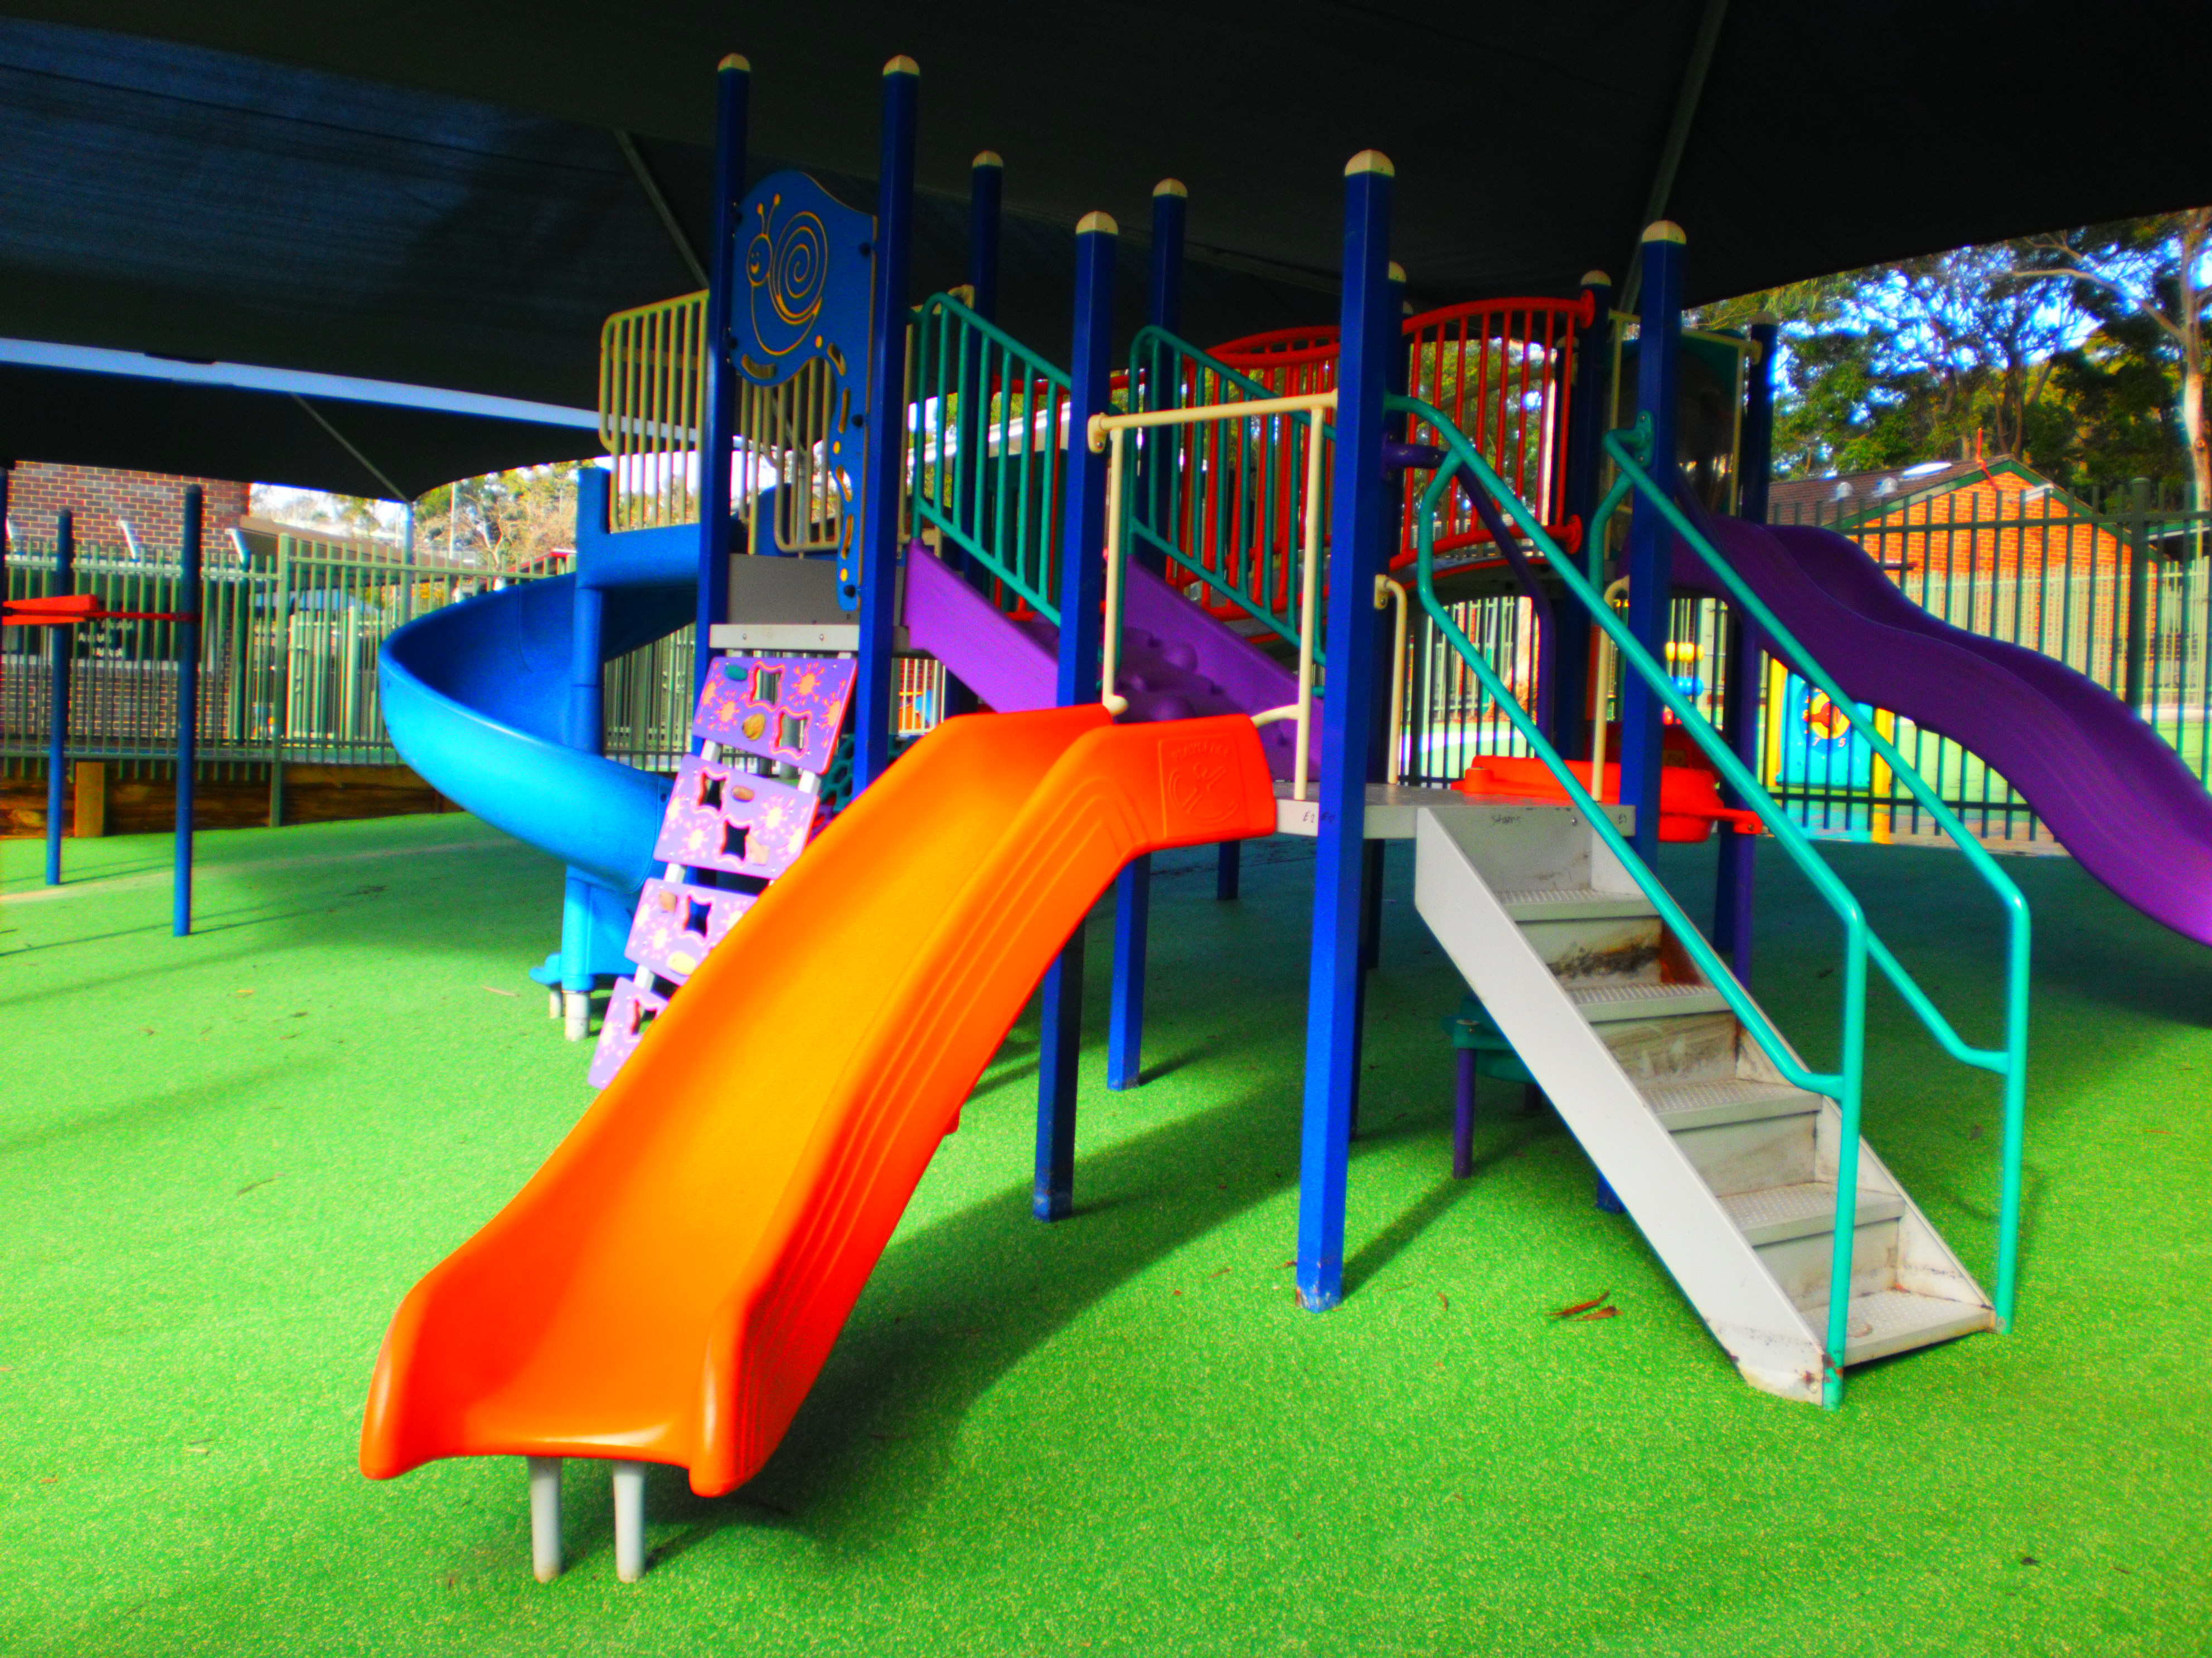

General Information

Assemblies
A school assembly is held once a week, normally on a Friday. The school population comes together to celebrate and recognise achievements by students in their academic and social endeavours. During the year the school has a number of special assemblies. Parents and friends are very welcome to attend and enjoy our celebrations.

Attendance Requirements
In NSW students must attend school regularly. This means all children between the ages of six and seventeen are legally required to attend school. Attendance is recorded daily and a 'roll call' is usually conducted before the first lesson of the day begins. Each family is provided with a booklet of absenteeism forms, which can be completed and returned to school explaining the reason for the child’s absence.
For the benefit of all children, parents or carers should ensure their child attends school regularly. Any absence from school should be explained within seven days of the absence. Similarly, schools are required to inform parents promptly of any unexplained absences or suspected truancy.
If you can only arrange your family holiday during school time, you should inform the school principal in advance and request leave.

Café Club
Parents and carers are invited one Thursday each term to come and share morning tea with other parents. This is an informal time where parents share ideas, issues and build a network of people with similar concerns and needs.

Communication Books
Each student will be given a communication book at the start of the year, which is used to forward information from school to parents and carers. Families are encouraged to read and respond to the information in the communication book. Open communication is very important to the success of the students’ placement and education.

Community Learning Programs
Students in Year 7 to 12 will be provided with the opportunity to participate in community learning programs. These are organised by the classroom teacher and address a number of outcomes in several key learning areas. Students are encouraged to participate to prepare them for post school placements.

Excursions
Schools participate in excursions to enhance and support classroom studies. They often provide practical experiences to extend learning in a particular area, for example, a visit an animal farm or park.

Family Law Related Issues
We know that some families experience breakdowns. In meeting our obligations to students and parents, the Department of Education and Communities relies on a number of basic principles. Among the most important are those schools’ decisions in relation to family issues will be based on what is considered to be in the best educational interests of the child. Also of paramount importance is the continued effective and efficient operation of the school.
We do not believe that schools are the place to resolve family disputes. Nor should school staff be involved in such disputes.
DEC has developed detailed guidelines to help schools deal with family law related issues. The guidelines are designed to balance the obligations and responsibilities of parents with the legal obligations of the school and its staff.
Parents have a responsibility to advise the school immediately if any change to family circumstances occur which has the potential to impact on the relationship between the school and the parents and/or students.
If court orders are obtained by one or both parents, a copy of the orders should be provided to the school as soon as possible. The school's decisions will be consistent with the court orders.
Unless schools are informed otherwise (e.g. being provided with a copy of the court orders), they will assume that both parents retain a shared and equal parental responsibility for their children. This means that the school will recognise that each parent has equal duties, obligations, responsibilities and opportunities in relation to matters involving their children's education at the school.

Hair cuts
Twice a term an experienced hairdresser comes to the school and cuts students’ hair (with parental permission). There is a cost associated with this service.

Head Lice
Head lice infestations are a common occurrence, particularly in primary schools.
- about 23% of primary students have head lice at any one time
anyone can catch head lice regardless of their age, sex, or how clean their hair is
- head lice move from one person's head to another via hair
- head lice do not survive long when they are off a human head
- head lice do not live on furniture, hats, bedding or carpet
- head lice have built up some resistance to head lice treatments
- daily combing of white hair conditioner using a fine tooth comb is effective in getting rid of head lice and eggs (nits)
- school communities may need to hold 'check and treat' or Nitbuster days where everyone learns about and starts treatment on the same day.
- information on effective treatment is essential to break the cycle of head lice infestation.

Immunisation
We support the immunisation of children, before they enter Kindergarten in NSW Public Schools, to protect them against outbreaks of infectious diseases. When enrolling a child, parents/caregivers will be asked to provide an Immunisation History Statement. The Immunisation History Statement can be obtained by contacting the Australian Childhood Immunisation Register on 1800 653 809. A child without an Immunisation History Statement will not be prevented from enrolling. Under the NSW Public Health Act 1991, however, children without proof of immunisation may be asked by Public Health Officials to stay at home during an outbreak of vaccine preventable disease.

Infectious and contagious diseases
Primary school students who do not have proof of immunisation may have to stay at home during an outbreak of a vaccine preventable disease at school. Particular arrangements will be worked out by the local public health unit in consultation with the school. Schools may notify parents of the outbreak so that families are aware of the symptoms. Below is a table showing the more common infectious diseases in children and the period they must be excluded.

Please advise the office immediately if your child is diagnosed with any infectious disease.

Chicken Pox | Excluded for 5 days from the onset of the rash and the blisters have dried.
Conjunctivitis | Excluded until discharge from eyes has ceased.
Gastroenteritis | Excluded for 24 hours after diarrhoea stops.
German Measles | Excluded for at least 4 days after the rash appears.
Glandular Fever | No exclusion unless sick
Hand Foot and Mouth Disease | Excluded until the blisters have dried.
Hepatitis A | Excluded for 2 weeks after the first symptoms or 1 week after the onset of jaundice.
Impetigo | Excluded until treatment starts. Sores should be covered with watertight dressings.
Measles | Excluded for 4 days after the rash appears.
Meningococcal Disease | Seek medical attention immediately. Patient will need hospital treatment.
Mumps | Excluded for 9 days from the onset of swelling
Ringworm | Excluded until the day after fungal treatment has begun.
Rubella | Excluded until fully recovered and for at least 6 days after the rash appears.
Scabies | Excluded until the day after the treatment has begun.
Scarlet Fever | Excluded until at least 24 hours of treatment has begun and the child is feeling better.
Slapped Cheek | No exclusion as it is most infectious before rash appears.
Whooping Cough | If the child has not received any antibiotic treatment then the child should be kept away from school for 3 weeks from the onset of the “whoop”. If appropriate and where antibiotic treatment is given the child only needs to be kept away from school for 5 days from the onset of erythromycin therapy.

Integration
If a student displays appropriate social and academic skills there should be an opportunity for the student to participate in an integration program at a selected primary or high school. This integration will be optional and must have the support of the student and their parents/carers.

Internet access and email
The NSW DEC provides your child with an internet and email account. Your child will have an individual username and password login to the internet at school. This means while at school, their access to the internet or World Wide Web will be filtered to ensure they cannot access inappropriate sites. Students are fully supervised and supported when accessing the internet.

Lunch and Recess
Lunch and recess breaks enable students to enjoy some fresh air, use the toilets and so on. It is also a great time to get some physical exercise.

Medication
When a medical practitioner has prescribed medication that must be administered during the school day, parents are responsible for:
- bringing this need to the attention of the school.
- ensuring that the information is updated if it changes.
- supplying the medication and any 'consumables' necessary for its administration in a timely way.
- collaborating with the school in working out arrangements for the supply and administration of the prescribed medication.
The administration of such medication forms part of the Department's common law duty of care to take reasonable steps to keep students safe while they attend school. This duty of care is fulfilled through its staff members.

Key points to remember:
- Parents or carers of children who require prescribed medication to be administered at school must complete a written request which must be authorised by a medical practitioner.
- The principal will provide the form to the parent.
If parents have difficulty in completing the form they should ask the principal for assistance.
- Please note: Students' immediate access to prescribed medication is very important for the effective management of conditions such as asthma. Students and parents need to be advised of this requirement so that students are not left without access to critical medication.
- It is the principal's responsibility to fully inform relevant staff of the management implications of students requiring the administration of prescribed medication.
- Except in an emergency, only individual staff members who have volunteered and been trained, will administer prescribed medication to students.
- The principal will oversee the implementation of the course of action that he or she has determined is necessary for the support of the student's health needs.
- It is the principal's responsibility to ensure that all copies of the written medical advice and any other relevant documentation are stored in a secure and confidential manner.

Advice or further information to assist the principal can be obtained from student welfare consultants and disability programs consultant.

All medication needs to be handed into the office or staff at the gates on arrival. On no account should medication be left in school bags where they are accessible to other students. All staff holds emergency care certificates.

Medical Clinics
There are two medical clinics held each term at the school. These generally occur on the second Thursday of each month. Attendance at one of the clinics is optional and on a needs basis. An appointment must be made prior to the date of the clinic to ensure that you and your child will be seen on that day.
The clinic is attended by Dr Robert Leitner, a developmental paediatrician from Kogarah Diagnostic and Assessment Service, his Registrar, Principal, Classroom Teacher, Parents and/or Carers.
The medical clinics provide the opportunity to discuss any issues or problems that you may be facing at home or school with your child. The cost of the appointment is covered by Medicare.

P & C Meetings
Our parents and citizens meet on Monday mornings at 9.30am once a term and Monday evening 7pm once a term. These meetings occur in week 3 and 8 of each term. The meetings are held in the meeting room. All parents and carers are welcome and encouraged to participate in the meetings and fund raising activities.

Professional Learning Days
Five times during the year the school staff, interested parents, carers and community members meet for the day to plan future directions for the school or to update information / policies. Students do not attend on these days.

Religious Education
Religious education is called “scripture” at Bates Drive School. Scripture lessons are held each Tuesday for our students in years Kindergarten to Year 6. The lessons are non denominational.

Reports – Interviews
During the year there will be opportunities for Parent/Teacher interviews. Learning Support Plan meetings and goal setting interviews are held in Term 1. These meetings set short term and long term goals for your child’s learning.
Your child will receive a report about his/her progress at the end of semester one. It will indicate which outcomes your child has achieved and which they are working towards. An end of year report will be provided in Term 4.
Should any problems or incidents at home arise that could affect your child’s education or well being, we ask that you inform the school so we can work together for the benefit of your child. If an interview is sought with the Principal, Executive Staff and/or Class Teachers, an appointment should be made by phone or via the student’s communication book.

Safety of Students
As soon as students enter the school grounds their safety and security is one of our priorities. The Department is committed to ensuring a safe and happy environment for your child.

School Counsellor
School counsellors work with students, parents or carers and teachers in a variety of ways.
Their work includes:
- counselling students
- assisting parents or carers to make informed decisions about their child's education
- assessing students' learning and behaviour
- assisting schools to identify and address disabilities that affect students' learning
- liaising with other agencies concerned with the well-being of students.

School counsellors are members of schools' student welfare and learning support teams. With the agreement of parents or carers, school counsellors will pass on information to teachers that will assist them to better meet the needs of their students.
Parents or carers may seek advice from school counsellors about their child's school progress, educational options, including access to special education services, behaviour and for information about help available from other agencies.

Consent is required before any psychological testing is undertaken.

Whether working with students, parents/carers, or teachers, school counsellors will explain how they work, listen carefully to what is said, help clarify options and encourage informed decision-making.

School Photographs
Each year professional photographers visit the school to take class and individual photographs. Parents are notified before they are taken and a pre-paid system operates. When the photographs arrive at school they are distributed immediately.

Voluntary School Contributions
Schools can request contributions to enhance the school's educational and sporting programs. These school contributions are voluntary and payment is a matter for decision by parents. They help provide additional educational resources for the benefit of students.
Schools may charge students for the purchase of materials used in particular subjects. Parents who cannot pay for elective programs because of financial hardship may be eligible for assistance from the Student Assistance Scheme or other appropriate sources.

Principals will ensure that no student or family suffers any discrimination or embarrassment over Voluntary School Contributions.
A letter will be sent home at the beginning of each school year. This contribution is paid to the P&C.

Volunteers
The establishment of strong links between home and school is highly desirable. The assistance of volunteers in the following areas is greatly appreciated: communication, sport, reading programs, mobility programs, as well as excursions. Volunteers must have a working with children clearance to support students in a school environment. This is available through the RMS.

If you are assisting in our school you must sign in at the office. This enables us to know who is in the school and in the case of an emergency assist with evacuation procedures.



